DROP TABLE departments;

DROP TABLE dept_emp;

DROP TABLE dept_manager;

DROP TABLE employees;

DROP TABLE salaries;

DROP TABLE titles;

CREATE TABLE departments (

dept_no VARCHAR PRIMARY KEY,

dept_name VARCHAR NOT NULL);

CREATE TABLE dept_emp (

emp_no INTEGER,

dept_no VARCHAR NOT NULL,

from_date VARCHAR NOT NULL,

to_date VARCHAR NOT NULL

);

CREATE TABLE dept_manager (

dept_no VARCHAR,

emp_no INTEGER,

from_date VARCHAR NOT NULL,

to_date VARCHAR NOT NULL

);

CREATE TABLE employees (

emp_no INTEGER,

birth_date VARCHAR NOT NULL,

first_name VARCHAR NOT NULL,

last_name VARCHAR NOT NULL,

gender VARCHAR NOT NULL,

hire_date VARCHAR NOT NULL

);

CREATE TABLE salaries (

emp_no INTEGER,

salary INTEGER NOT NULL,

from_date VARCHAR NOT NULL,

to_date VARCHAR NOT NULL

);

CREATE TABLE titles (

emp_no INTEGER,

title VARCHAR NOT NULL,

from_date VARCHAR NOT NULL,

to_date VARCHAR NOT NULL

);

SELECT * FROM departments;

SELECT * FROM dept_emp;

SELECT * FROM dept_manager;

SELECT * FROM employees;

SELECT * FROM salaries;

SELECT * FROM titles;

-- (1) List the following details of each employee:

--employee number, last name, first name, gender, and salary.

SELECT e.emp_no, e.first_name, e.last_name, e.gender, s.salary

FROM employees AS e

INNER JOIN salaries AS s ON

e.emp_no=s.emp_no;

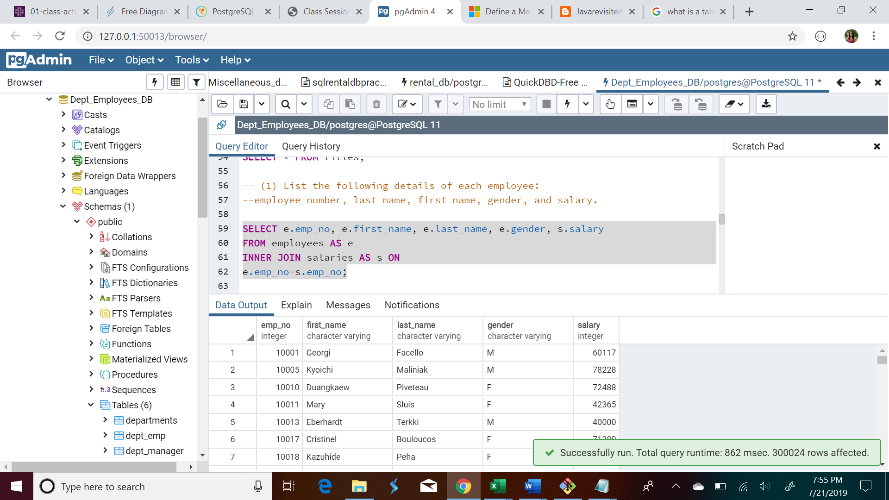

-- (2) List employees who were hired in 1986.

SELECT e.emp_no, e.first_name, e.last_name, e.hire_date

FROM employees AS e

WHERE hire_date LIKE '1986%';

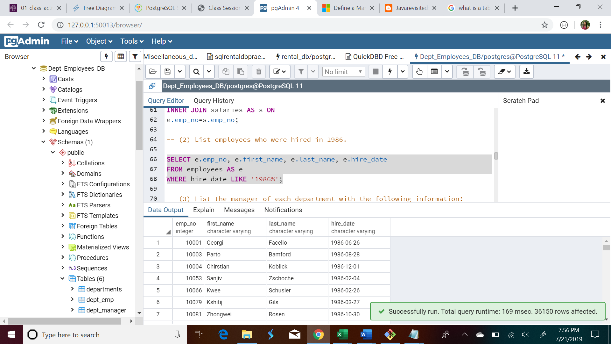

-- (3) List the manager of each department with the following information:

--department number, department name, the manager's employee number,

--last name, first name, and start and end employment dates.

SELECT d.dept_no, d.emp_no, d.from_date, d.to_date, e.first_name,

e.last_name, de.dept_name

FROM dept_manager AS d

INNER JOIN employees AS e ON

d.emp_no=e.emp_no

INNER JOIN departments AS de ON

d.dept_no=de.dept_no;

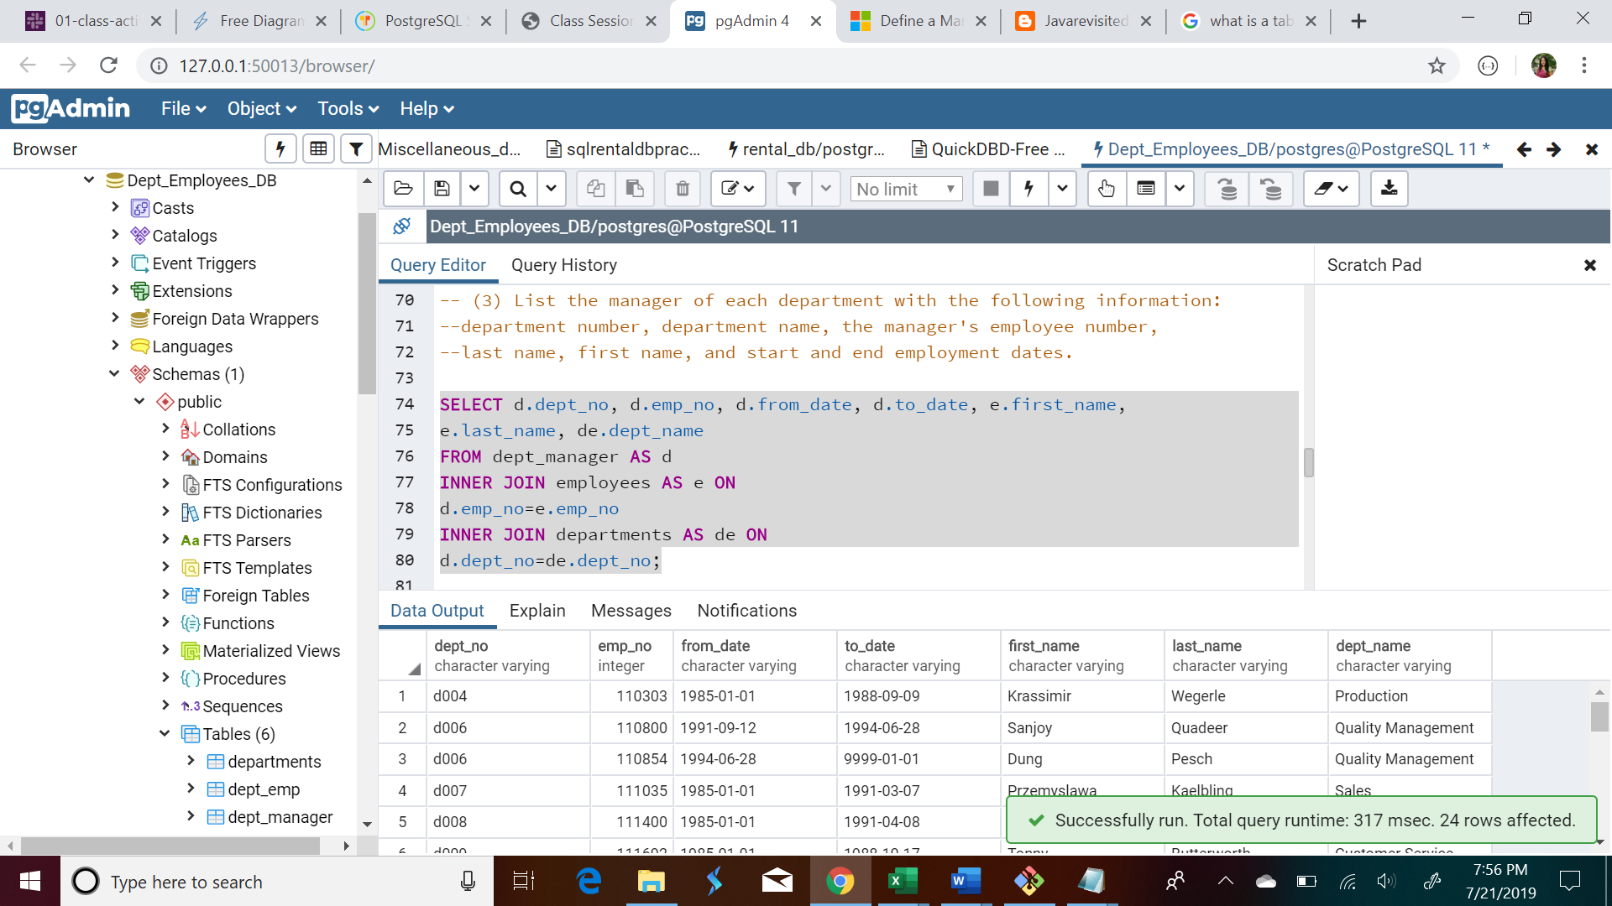

-- (4) List the department of each employee with the following information:

-- employee number, last name, first name, and department name.

SELECT e.emp_no, e.first_name, e.last_name, de.dept_name

FROM employees AS e

INNER JOIN dept_emp AS d ON

e.emp_no=d.emp_no

INNER JOIN departments AS de ON

d.dept_no=de.dept_no;

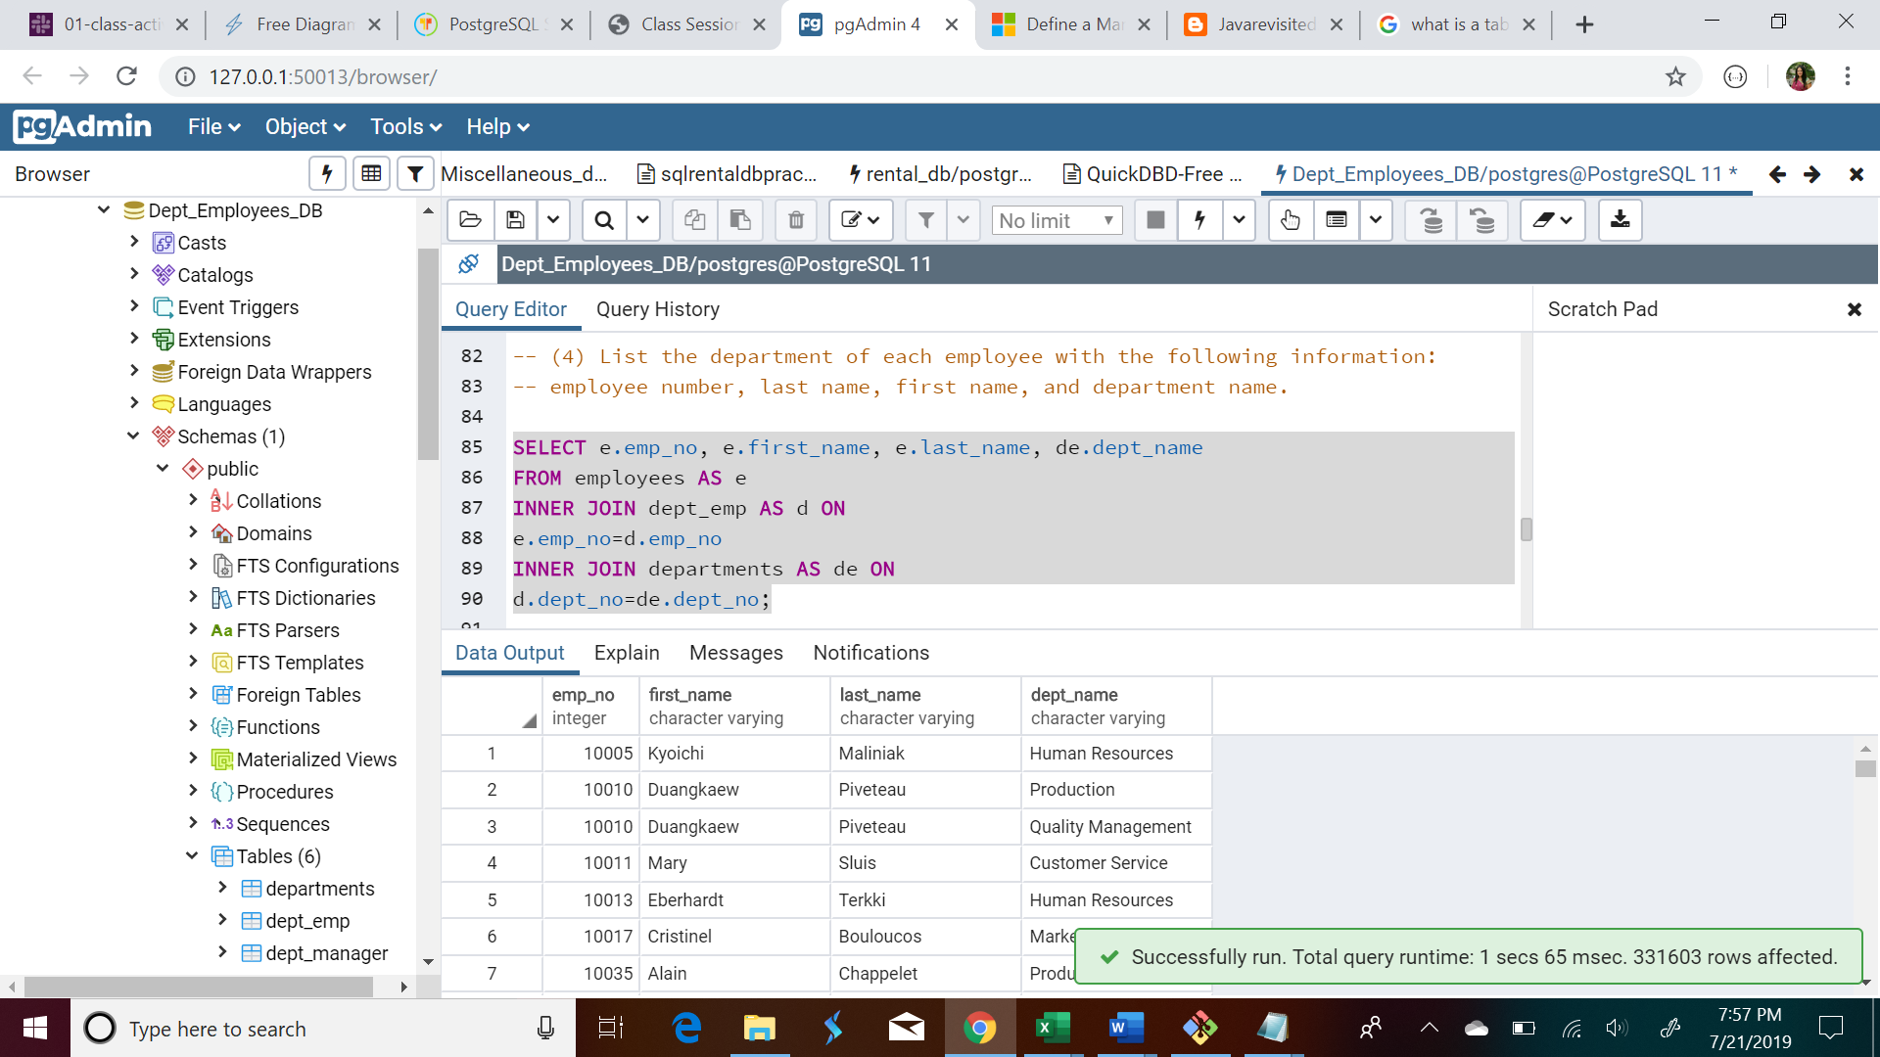

-- (5) List all employees whose first name is "Hercules"

-- and last names begin with "B."

SELECT * FROM employees

WHERE first_name = 'Hercules' AND last_name LIKE 'B%';

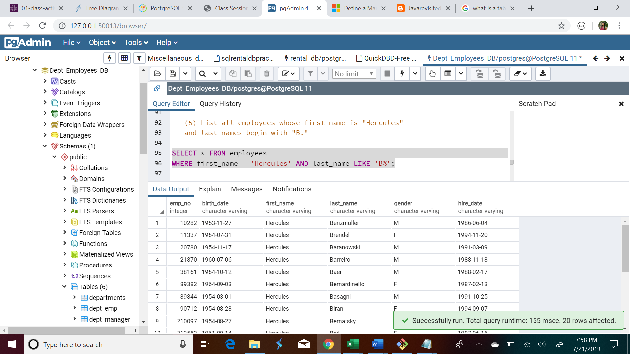

-- (6) List all employees in the Sales department, including their

-- employee number, last name, first name, and department name.

SELECT e.emp_no, e.first_name, e.last_name, de.dept_name

FROM employees AS e

INNER JOIN dept_emp AS d ON

e.emp_no=d.emp_no

INNER JOIN departments AS de ON

d.dept_no=de.dept_no

WHERE dept_name = 'Sales';

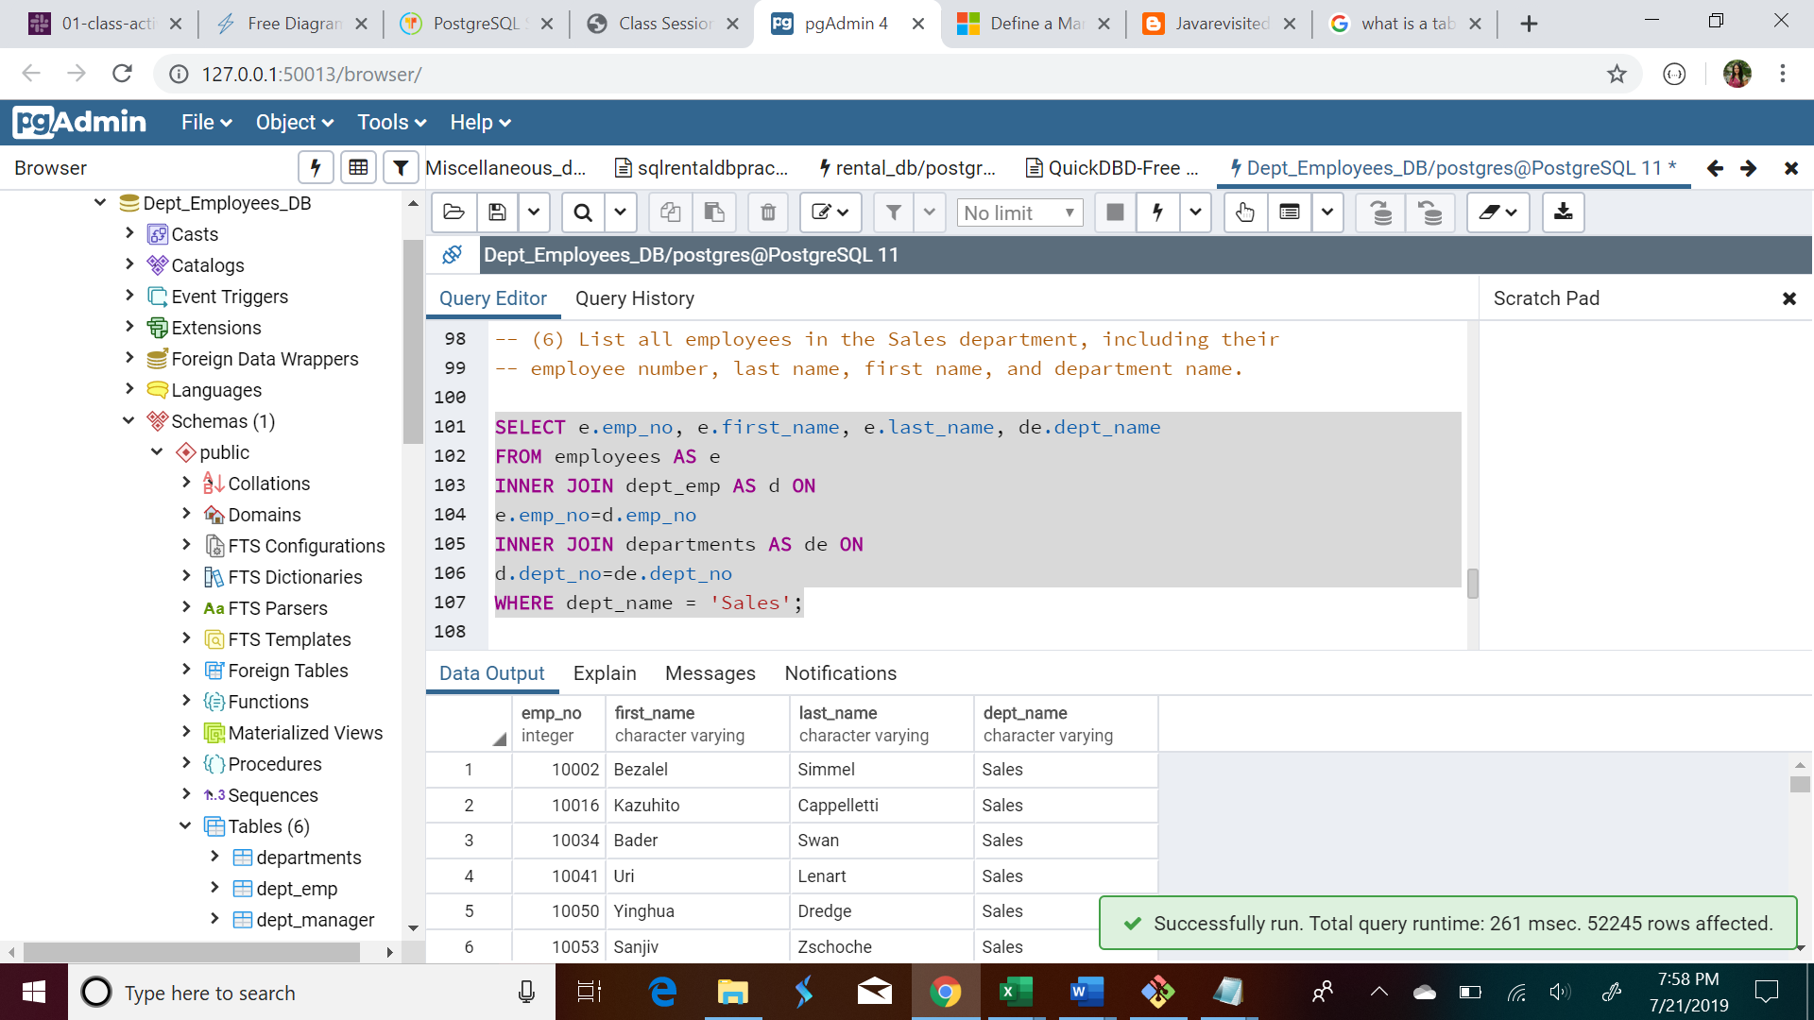

-- (7) List all employees in the Sales and Development departments,

-- including their employee number, last name, first name, and department name.

SELECT e.emp_no, e.first_name, e.last_name, de.dept_name

FROM employees AS e

INNER JOIN dept_emp AS d ON

e.emp_no=d.emp_no

INNER JOIN departments AS de ON

d.dept_no=de.dept_no

WHERE dept_name = 'Sales' OR dept_name = 'Development';

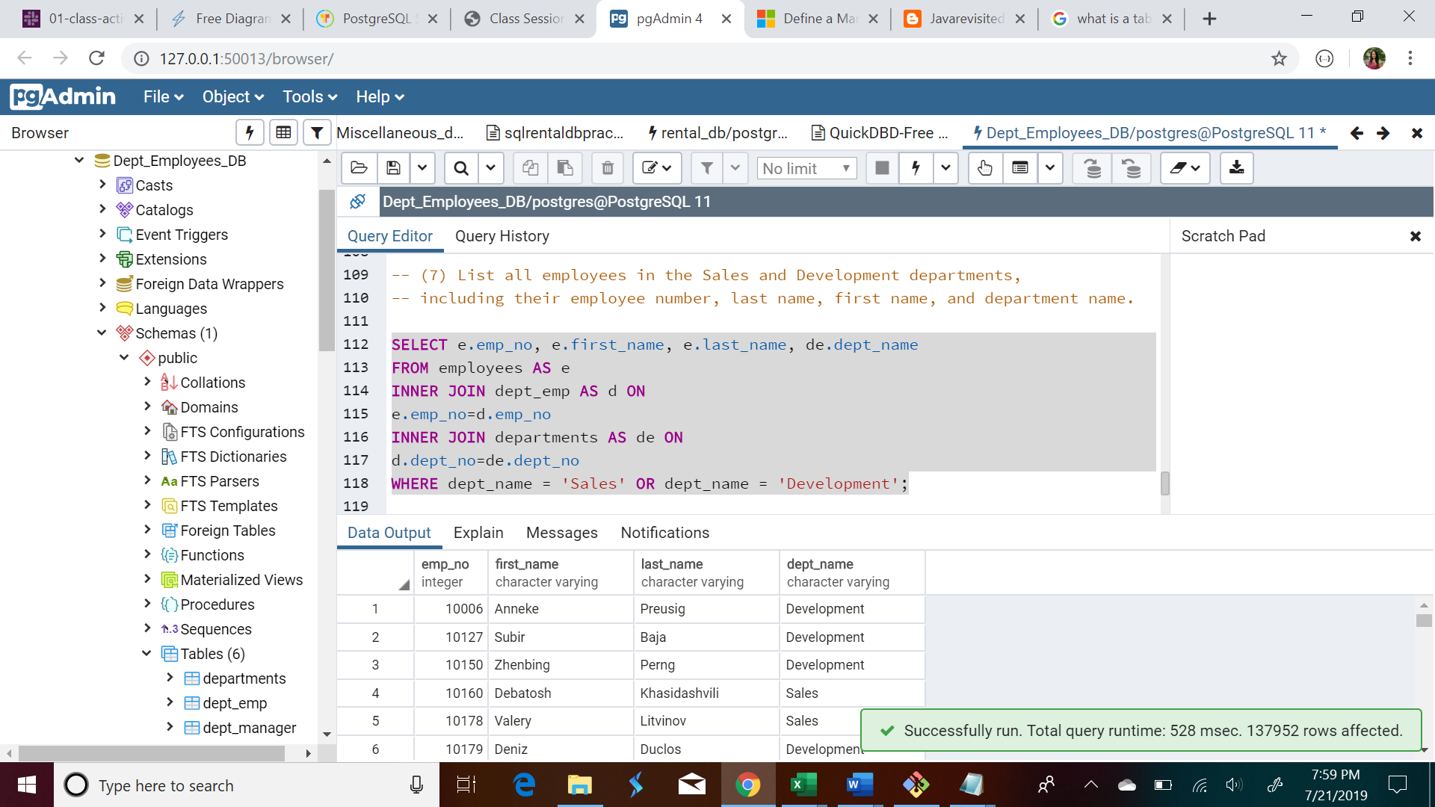

-- (8) In descending order, list the frequency count of employee last names,

-- i.e., how many employees share each last name.

SELECT last_name, COUNT(last_name) AS "Last Name Count"

FROM employees

GROUP By last_name

ORDER BY "Last Name Count" DESC;

